1、磁带最优存储问题
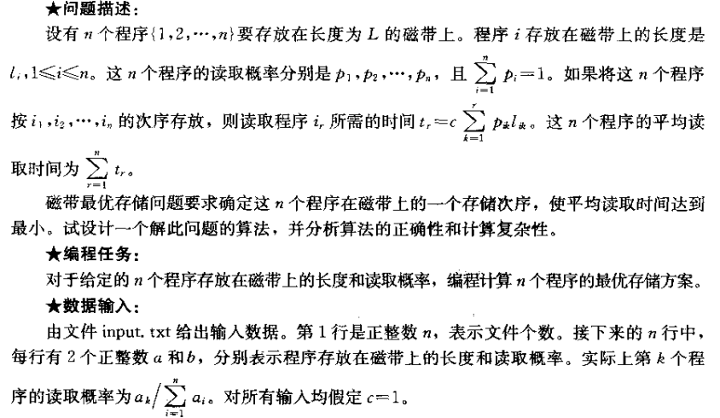
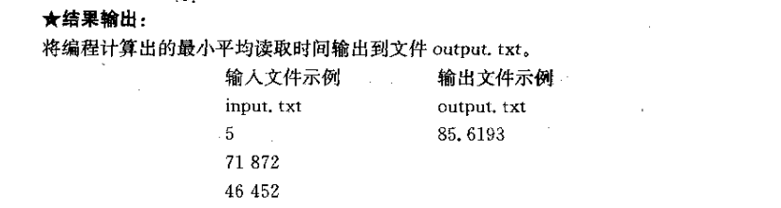

'''
越是放在前面，读取的次数越是多。所以放在前面的用时尽量小
贪心的思想
'''
def solution(rate,length,n):
multiResult = []
sumRate = sum(rate)
for i in range(len(rate)):
rate[i] = rate[i]/sumRate
for i in range(n):
tmp = rate[i]*length[i]
multiResult.append(tmp)
multiResult.sort()
Sum = 0
for i in range(n):
Sum += multiResult[i]*(n-i)
return Sum
if __name__ == '__main__':
n = 5
rate = [872,452,265,120,87]
length = [71,46,9,73,35]
res = solution(rate,length,n)
print(res)

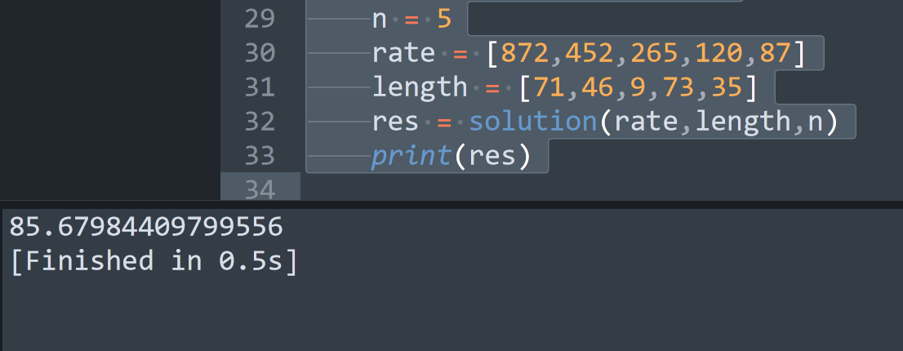

2、磁盘文件最优存储问题
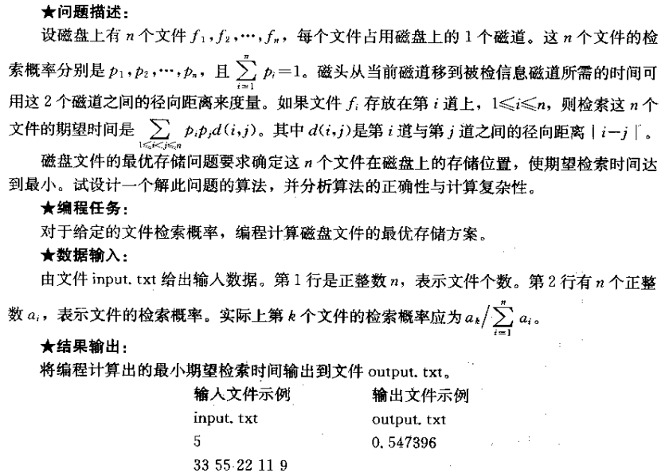

'''
保证差距最远的两个磁道的概率最小
'''
def solution(k,alist):
sumRate = sum(alist)
rate = [i/sumRate for i in alist]
rate.sort()
j = 0
k = 0
result = 0
tmp = rate.copy()
for i in range(len(rate)):
if i %2 == 0:
tmp[0+j] = rate[i]
j += 1
else:
tmp[-1-k] = rate[i]
k += 1
for i in range(len(tmp)):
for j in range(i+1,len(tmp)):
result += tmp[i]*tmp[j]*(j-i)
return result

if __name__ == '__main__':
rate = [33, 55, 22, 11, 9]
k = 5
res = solution(k,rate)
print(res)

